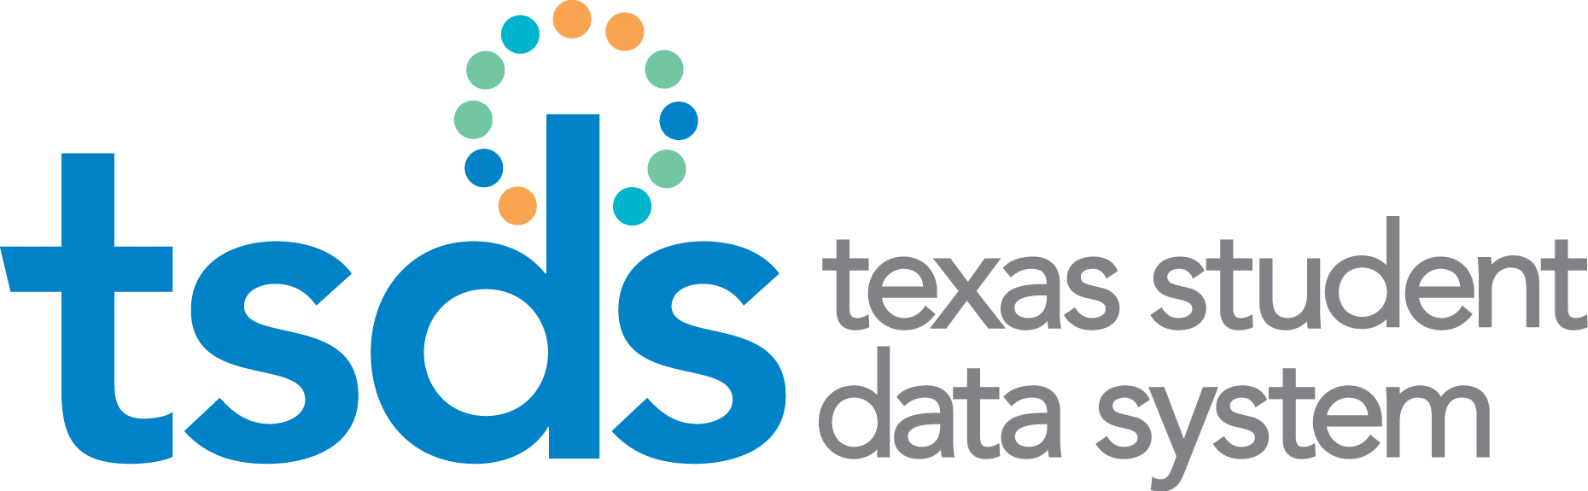

Texas Education Data Standards (TEDS)

2019-2020 Cumulative Change Log – Section 4 / 8.4

Preliminary Version 2020.0.0
December 1, 2018

Prepared by: Information Technology Services Business Management Division

Table of Contents
TSDS & PEIMS Code Table Changes 3
C022 – SERVICE-IDS 3
C159 – OBJECT-CODE 3
C161 – STUDENT-ATTRIBUTION-CODE 3
C171 – SSI-PROMOTION-RETENTION-CODE 4
C214 – INDUSTRY-CERTIFICATION-LICENSURE-CODE 4
C218 – ELO-TYPE (NEW) 4
TSDS Only Code Table Changes 5

NEW = this indicates that the code table and code(s) are new to TEDS
ADDED = this indicates that the code is new to the code table which already exists in TEDS
REVISED = this indicates that the code has been updated in TEDS
DELETED = this indicates that the code table/code has been deleted from TEDS

TSDS & PEIMS Code Table Changes

C022 – SERVICE-IDS
VERSION | CODE | PREVIOUS ENTRY | CURRENT ENTRY | ACTION
2020.0.0 | 03200531 |  | English Learners Language Arts (ELLA), Grade 7 | ADDED
2020.0.0 | 03200532 |  | English Learners Language Arts (ELLA), Grade 8 | ADDED
2020.0.0 | 03380084 |  | Ethnic Studies: Mexican American Studies | ADDED
2020.0.0 | N1130023 | Mexican American Studies |  | DELETED
2020.0.0 | 03150600 | Music II,I Orchestra II | Music II, Orchestra II | REVISED
2020.0.0 | 03580140 | CTE Course: BLANK | CTE Course: H | REVISED
2020.0.0 | 03580200 | CTE Course: BLANK | CTE Course: H | REVISED
2020.0.0 | 03580360 | CTE Course: BLANK | CTE Course: H | REVISED
2020.0.0 | A3580300 | CTE Course: BLANK | CTE Course: H | REVISED

C159 – OBJECT-CODE
VERSION | CODE | PREVIOUS ENTRY | CURRENT ENTRY | ACTION
2020.0.0 | 6491 |  | Statutorily Required Public Notices | NEW

C161 – STUDENT-ATTRIBUTION-CODE
VERSION | CODE | PREVIOUS ENTRY | CURRENT ENTRY | ACTION
2020.0.0 | 29 |  | South Texas ISD [For South Texas ISD Use Only] | NEW

C171 – SSI-PROMOTION-RETENTION-CODE
VERSION | CODE | PREVIOUS ENTRY | CURRENT ENTRY | ACTION
2020.0.0 | 07 | 5th Grade Student In Previous School Year Did Not Perform Satisfactorily On The Reading And Mathematics Assessment Instruments And Is Promoted Yo 6th Grade Or Higher In Current School Year By Decision Of His Or Her Grade Placement Committee Even Though The Student Did Not Meet The SSI Requirements (for students enrolled in 5th grade in 2004-2005 and thereafter) | 5th Grade Student In Previous School Year Did Not Perform Satisfactorily On The Reading And Mathematics Assessment Instruments And Is Promoted To 6th Grade Or Higher In Current School Year By Decision Of His Or Her Grade Placement Committee Even Though The Student Did Not Meet The SSI Requirements (for students enrolled in 5th grade in 2004-2005 and thereafter) | NEW

C214 – INDUSTRY-CERTIFICATION-LICENSURE-CODE
VERSION | CODE | PREVIOUS ENTRY | CURRENT ENTRY | ACTION
2020.0.0 | 000 | Not Applicable |  | DELETED

C218 – ELO-TYPE (NEW)
VERSION | CODE | PREVIOUS ENTRY | CURRENT ENTRY | ACTION
2020.0.0 | 01 |  | Non-Voluntary Extended School Day (Submission 3 Only) | NEW
2020.0.0 | 02 |  | Non-Voluntary Extended School Year (Submission 3 Only) | NEW
2020.0.0 | 03 |  | Voluntary Expanded Learning - Before School and After School (Submission 3 Only) | NEW
2020.0.0 | 04 |  | Voluntary Expanded Learning - Summer (Submission 4 Only) | NEW

NEW = this indicates that the code table and code(s) are new to TEDS
ADDED = this indicates that the code is new to the code table which already exists in TEDS
REVISED = this indicates that the code has been updated in TEDS
DELETED = this indicates that the code table/code has been deleted from TEDS

TSDS Only Code Table Changes

There are no TSDS Only Code Table changes for the Preliminary TEDS publication.

